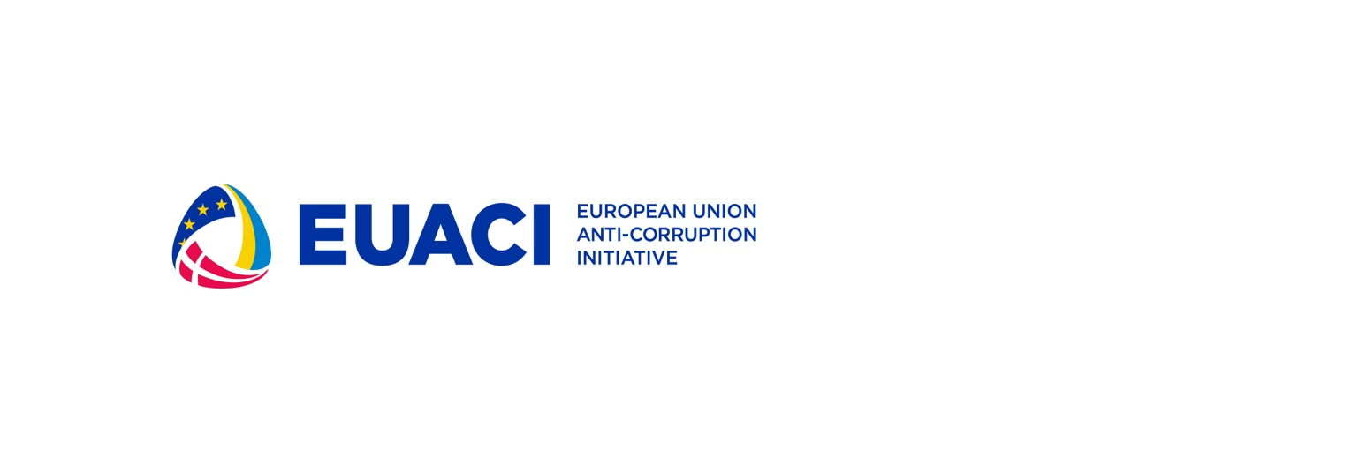

**Strategic Communication Expert on Anti-Corruption**

**Terms of Reference**

27 February 2023

# Background and context

* 1. **General overview**

EU Anti-Corruption Initiative is the biggest EU support programme in the area of anti-corruption in Ukraine. The EUACI began in 2017 and has since established itself as a flagship program.

The overall objective of the EU Anti-Corruption Initiative Phase II is to improve the implementation of Ukraine’s anti-corruption policy by supporting the key anti-corruption state institutions, including the support of communication activities.

To ensure trust in the anti-corruption infrastructure and promote the anti-corruption agenda it’s important to strengthen the communication capacity of the anti-corruption institutions and assist them in strategic communications.

Thus, by this procurement, the EUACI will contract the strategic communication expert to assist communication teams and leaders of the anti-corruption institution (NACP, HACC, NABU, SAPO and ARMA), and the EUACI with advice and assistance in promoting the anti-corruption agenda.

* 1. **Contracting authority**

The contracting authority is the European Union Anti-Corruption Initiative.

* 1. **Beneficiary**

The beneficiaries are the National Agency on Corruption Prevention, the National Anti-Corruption Bureau of Ukraine, the Specialized Anti-Corruption Prosecutor’s Office, the High Anticorruption Court, the Asset Tracing and Management agency, and the European Union Anti-Corruption Initiative.

# Objective

The main objective of technical support to be provided within the framework of this engagement is to contribute to the effective strategic communication of the anti-corruption institutions and the EUACI.

1. **Scope of work and expected deliverables**

**Scope of work**

A strategic communication expert will be working on the fulfillment of the following tasks:

* strategic and ad-hoc consultations and training sessions to the communications experts and heads of anti-corruption institutions;
* developing communication campaigns and plans;
* conduct a strategic communication session for the EUACI staff to form a communication strategy during the war;
* conducting nedia training (upon request);
* providing suggestions for communication initiatives during EUACI Phase III;
* other tasks related to communications.

A strategic communication expert will be expected to work in close coordination with EUACI’s representatives and will be required to report on the implementation of tasks.

**Expected deliverables:**

* At least 10 consultations provided to the communications experts and heads of anti-corruption institutions;
* At least three communication campaigns for the EUACI and AC institutions developed (including communication plans, key messages, tools, resources, expected results);
* At least 1 media training provided;
* 1 session on strategic communication for the EUACI staff held;
* Written report with recommendations for strengthening the EUACI communications.

1. **Timeline**

The intended commencement date is the date of signature of the contract with a consultant and the period of implementation of the contract will be 1 year, with a duration of 120 working days.

1. **Professional Requirements**

Education and Experience:

* A university degree in journalism or other related disciplines;
* 5 years of relevant professional experience as a communication expert or communication adviser, with a focus on justice/rule of law/anti-corruption field;
* Proven experience in conducting communication services;
* Knowledge of the media landscape of Ukraine is obligatory;
* Excellent analytical and communication skills;
* Previous experience working with/knowledge of anti-corruption reform in Ukraine;
* Knowledge of the anti corruption institutions and their challenges in terms of communication and media
* Fluency in written and oral Ukrainian and English.

1. **Monitoring and evaluation**

Definition of indicators

The contractor's performance will be judged upon reaching this contract's purpose and obtaining its results, as indicated in the sections "Objective" and "Expected Deliverables" herein respectively. Moreover, the performance of the contractors will be judged upon the successful implementation of all the specific activities indicated above.

Special requirements

By signing the contract, the contractors agree to hold in trust and confidence any information or documents ("confidential information"), disclosed to the contractors or discovered by the contractors or prepared by the contractors in the course of or as a result of the implementation of the contract, and agrees that it shall be used only for the purposes of the contract implementation and shall not be disclosed to any third party.

The contractor reports to the EUACI. The contractor shall be briefed prior to starting with the assignment. The contractor shall de-brief the EUACI prior to finalising the assignment.

The contractor shall immediately inform the EUACI after 50% and again after 75% use of the overall foreseen working days under this contract.

# Bidding details

The bidder must submit the following information to be considered:

1. The CV;
2. A list of similar assignments, executed in the last five years;
3. Memo on the approach to fulfilling this TOR (two pages maximum)
4. Budget for the services in EUR, inclusive of all taxes or other such charges.

# How to apply

The deadline for submitting the proposals is 13 March 2023, 18:00 Kyiv time.

The proposals shall be submitted within the above deadline to yanryz@um.dk, indicating the subject line “**StrategicCommunication Expert on Anti-Corruption**”,

Bidding language: English.

Any clarification questions for the bid request should be addressed to yanryz@um.dk, no later than 6 March 2023, 18:00 Kyiv time.

# Evaluation criteria

Bids will be evaluated under the criteria provided below:

|  |  |  |
| --- | --- | --- |
| **#** | **Criteria** | **Weight** |
| 1 | Experience, skills, and competencies | 70% |
| 3 | Proposed budget | 30% |